Trade of Sheet Metalwork
Module 7: | Introduction to CNC Sheet Metal Manufacturing
Unit 6: | Tooling & Material Handling
 | Phase 2

Table of Contents
List of Figures 5
List of Tables 6
Document Release History 7
Module 7 – Introduction to CNC Sheet Metal Manufacturing 8
Unit 6 – Tooling & Material Handling 8
Learning Outcome: 8
Key Learning Points: 8
Training Resources: 8
Key Learning Points Code: 8
Tooling 9
Tooling Types 9
Tool Selection for Punch/Press Brake 11
Material Handling 11
Press Brake Geometrics 11
Combination of Dies and Punches 12
Reduce your Forming Costs with Standard 13
How to Read the Pressure Chart 14
Formula for Loads for Air-Bends 15
Standard Tool Setup 17
Standard Tang Detail 18
Bronx Standard Bottom Tools 19
Correct Size of Vee for Each Gauge 19
The Golden Rule 20
Tool Setting 20
CNC Coursework Assessment 21
Self Assessment 22
Answers to Questions 1-2. Module7.Unit 6 23
Index 24

List of Figures
Figure 1 - A, B Types 8
Figure 2 - C Type 9
Figure 3 - Combination of Dies and Punches 11
Figure 4 - Reduce your Forming Costs with Standar 12
Figure 5 - Pressure Chart 13
Figure 6 - Simple Standard Tools Making a 90° Air Bend 15
Figure 7 - Standard Tool Setup 16
Figure 8 - Type T1, T5 and T3 17
Figure 9 - Type B1 18

List of Tables
Table 1 14
Table 2 14
Table 3 17
Table 4 18
Table 5 - Size of Vee Width or Opening for Various Gauges (8:1 Die Ratio) 18

Document Release History
Date | Version | Comments
22/01/07 | First draft
09/04/14 | 2.0 | SOLAS transfer

Module 7 – Introduction to CNC Sheet Metal Manufacturing

Unit 6 – Tooling & Material Handling
Duration – 7 Hours

Learning Outcome:
By the end of this unit each apprentice will be able to:
- Select, define and calibrate tooling for punching and forming
- State the precautions to be observed while manually changing a tool on a CNC machine
- Identify and describe single station and multi-station turret punch presses
- Select and install suitable workholding arrangements
- Load workpieces and install tooling

Key Learning Points:
Sk | Tool setting on machines, measurement and adjustment of tooling, material handling and manipulation, workpiece setting in machine.
Sk Rk | Identification and selection of tooling. Press Brake Geometrics, tooling specifications, storage racks for tool change systems, precision measuring equipment.

Training Resources:
- CNC Punch Press
- CNC Press Brake
- Samples of tools
- Machine manufacturer’s specifications

Key Learning Points Code:
M = Maths D= Drawing RK = Related Knowledge Sc = Science
P = Personal Skills Sk = Skill H = Hazards

Tooling

Tooling Types
Tooling types used for this machine include the following:

A type: Max. diameter ø15}
B type: Max. diameter ø 40}
C type: Max. diameter ø 100}
Tooling form: Round, regular square, oblong, oblong with curved sides, etc.

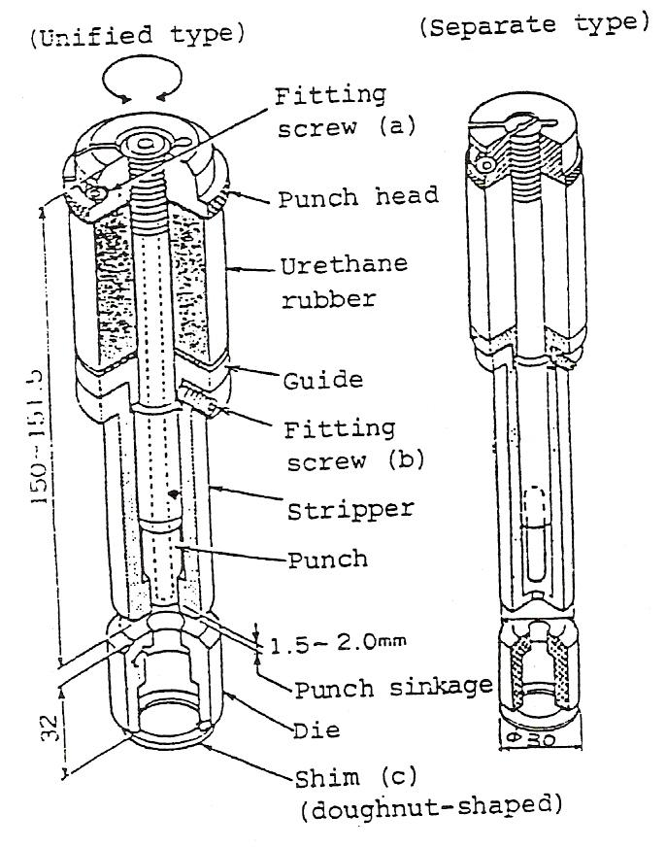
Figure 1 - A, B Types

Before setting tooling on turret, check as follows:
- Confirm that punch sinks 1.5 to 2.0mm.
-- Adjust from punch head screw part.
-- Check fitting screw (a) in order to prevent height gap caused by loosened screw during working.
- Confirm that punch upper part does not protrude from punch head.
- Confirm that die height is 32mm.
-- After re-grinding, etc., set the height to 32mm by inserting shim (c). (Allowable tolerance is within 0.5mm.) Shim is sold by us.
Notes:
- When tooling has directional property (other than round type), install it after confirming key position. An error will lead to tooling damage.
- Punch may sink insufficiently (due to loosened punch head screw) during working. Check for this at appropriate intervals.
- Tighten fitting screw (b) so that stripper does not slip, but not too firmly.
- Toolings of øl.0 to ø5.0 have no air eject hole.
- Designate B type when thick plate is to be punched with a tooling of øl0 to ø15.
- Toolings of more than ø30 have shear angle.

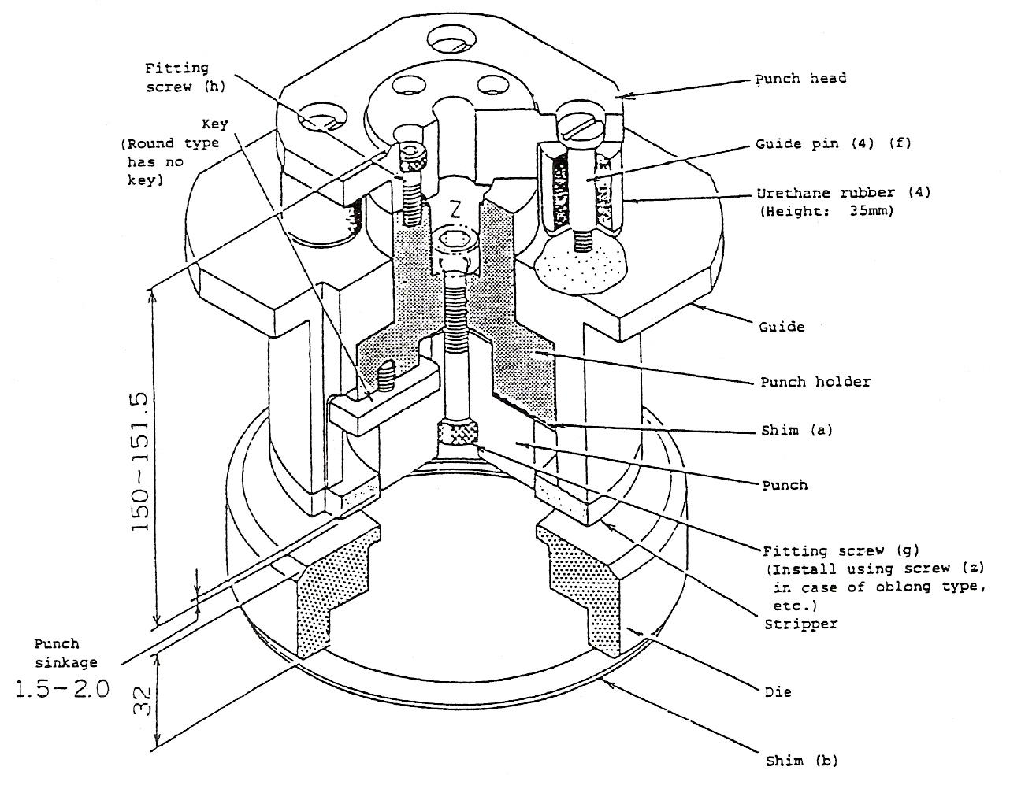
Figure 2 - C Type

Tool Selection for Punch/Press Brake
When selecting tooling for machinery we take into consideration:

- Material type
- Material thickness
- Nature (shape) of workpiece, e.g. size of workpiece

Before we install tooling in the punch press or press brake, we must first ensure that we:

- Select correct tooling for job at hand
- Check condition of tooling
- Check calibration of tooling (i.e. Depth for embossing – countersink etc.)
- Check tonnage if applicable. Formula = (3.14 x thickness x dia. x 25 = tonnage)

Material Handling
It is essential the workpiece is positioned accurately. For this to happen the sheet must hit the locating pin and be securely held by the clamps. The clamps also act as a datum point.

The machine capacity can be increased by manipulation of the workpiece, i.e. turning it around 90° and/or 180°.

Press Brake Geometrics
Before starting a job with the press brake it is essential to know the job can be bent around the machine. This means the body of the press brake will not interfere with the actual metal, i.e. folding sequence. For further details see Precision Unit 14, Module 1.

Combination of Dies and Punches
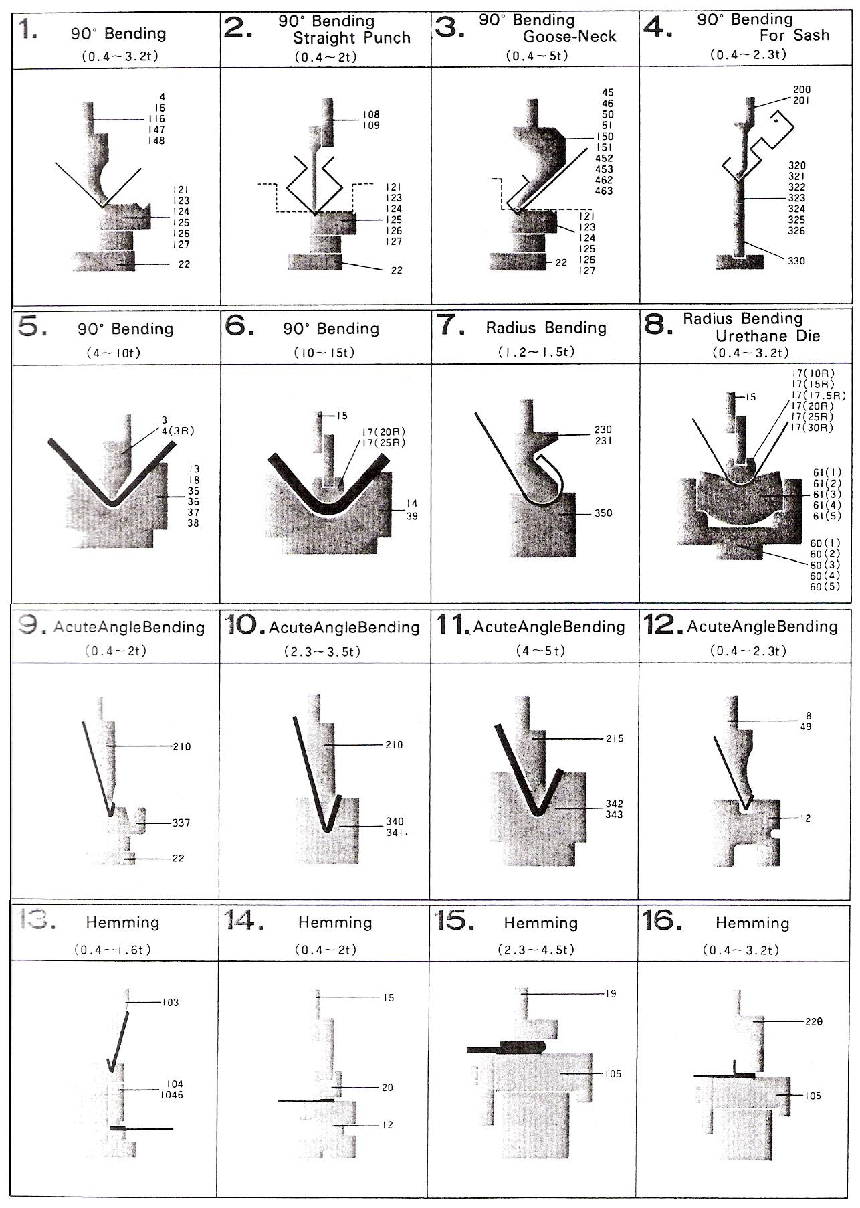
Figure 3 - Combination of Dies and Punches

Reduce your Forming Costs with Standard
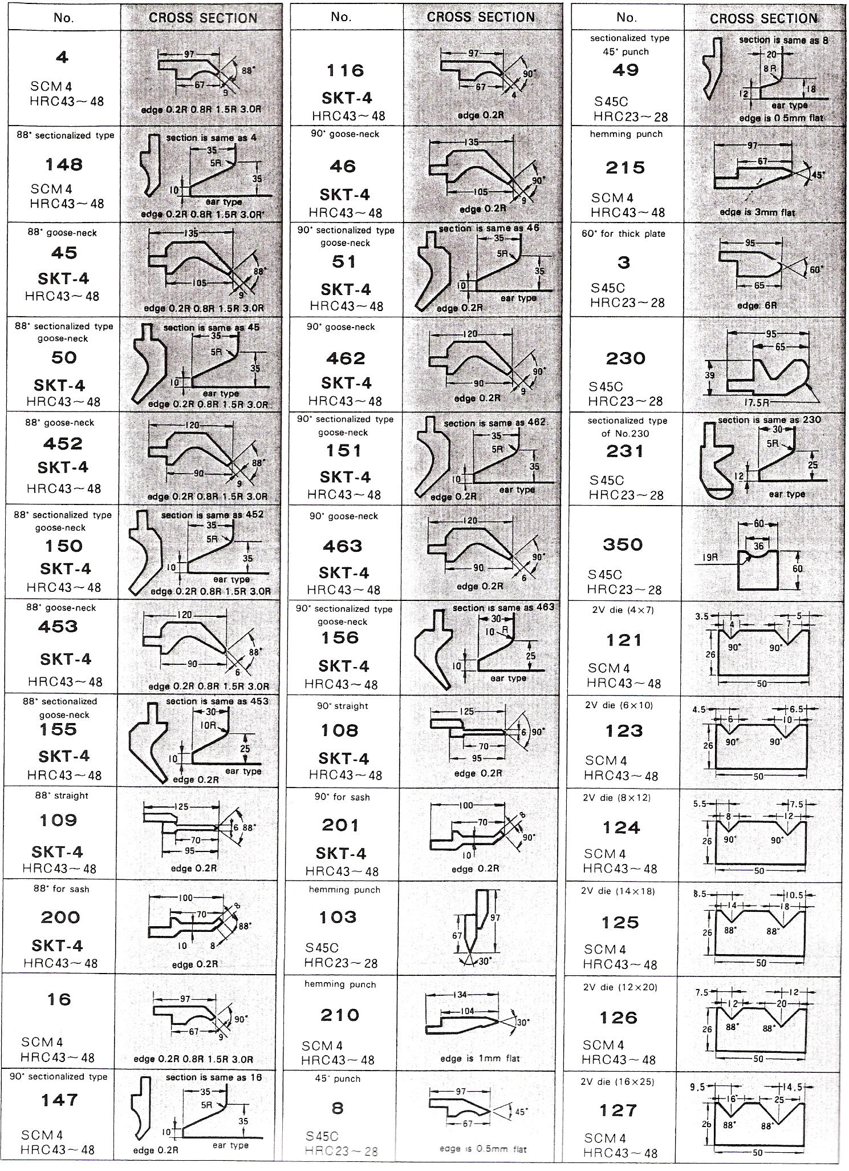
Figure 4 - Reduce your Forming Costs with Standar

How to Read the Pressure Chart
If the material thickness and inner bending radius are known, the following can be obtained from the chart below:

- Pressure required for bending the material of 1 metre.
- Opening of the die to be used.
- Minimum bendable flange length.

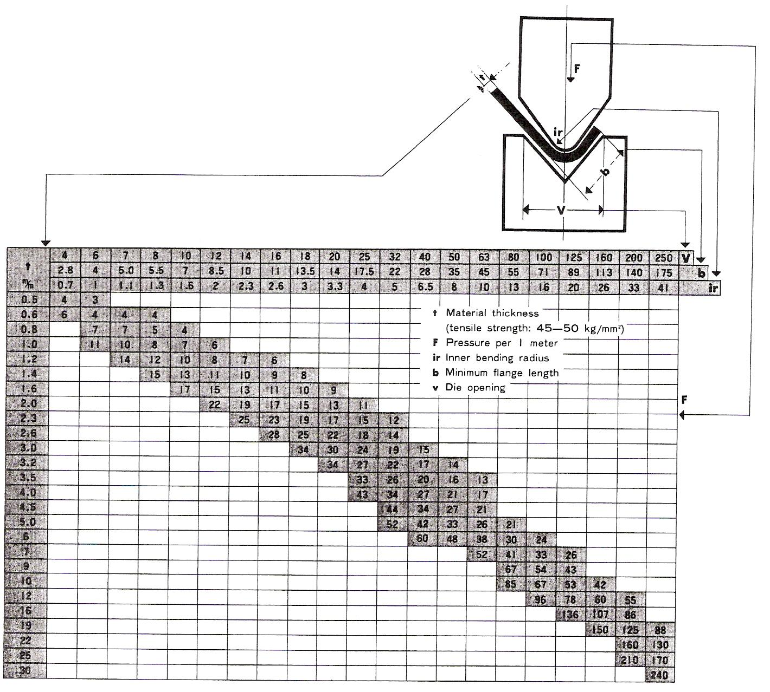
Figure 5 - Pressure Chart

Formula for Loads for Air-Bends
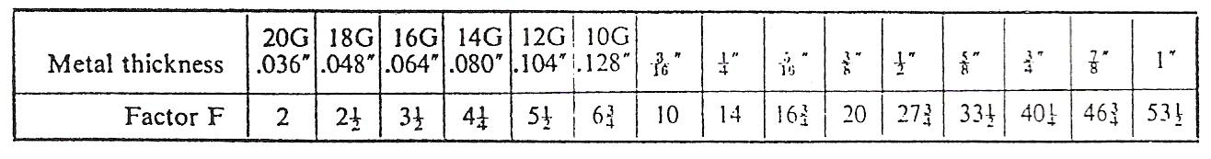
Table 1

The load to bend any thickness and length of plate under air-bend conditions, to a right angle can be calculated from the following formula:
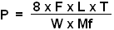
P = Load to bend in tons
F = Factor from Table 1 above
L = Length of metal to be bent in feet
T = Thickness of metal in inches
W = Width of die opening in inches
Mf = Material factor from Table 2 below

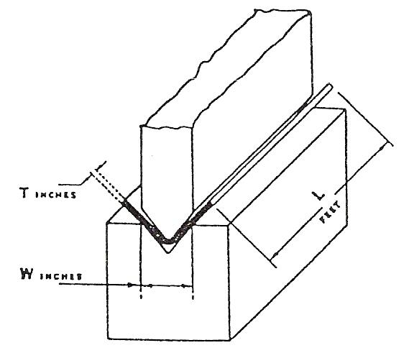

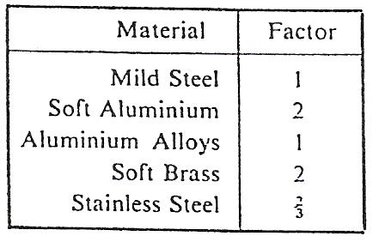
Table 2
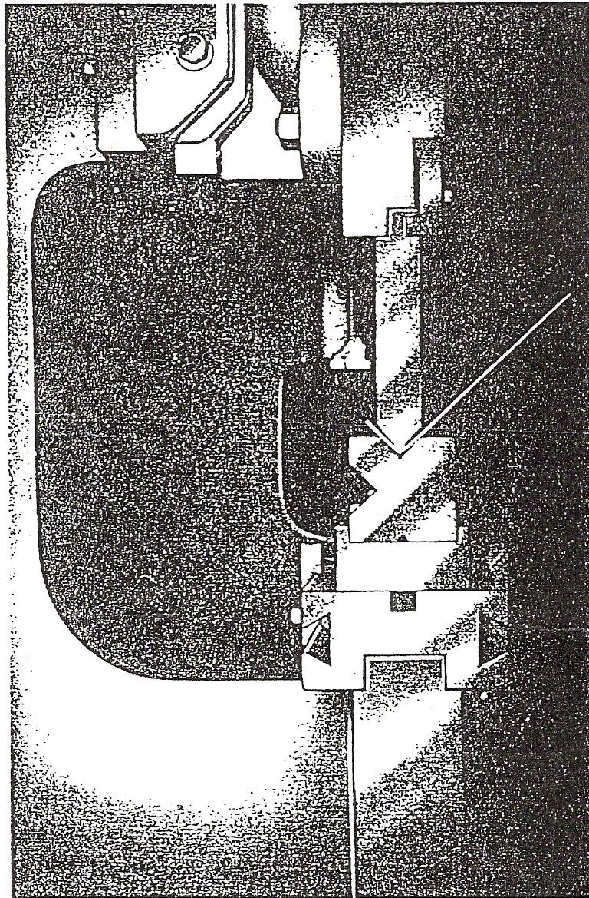
Figure 6 - Simple Standard Tools Making a 90° Air Bend

Standard Tool Setup
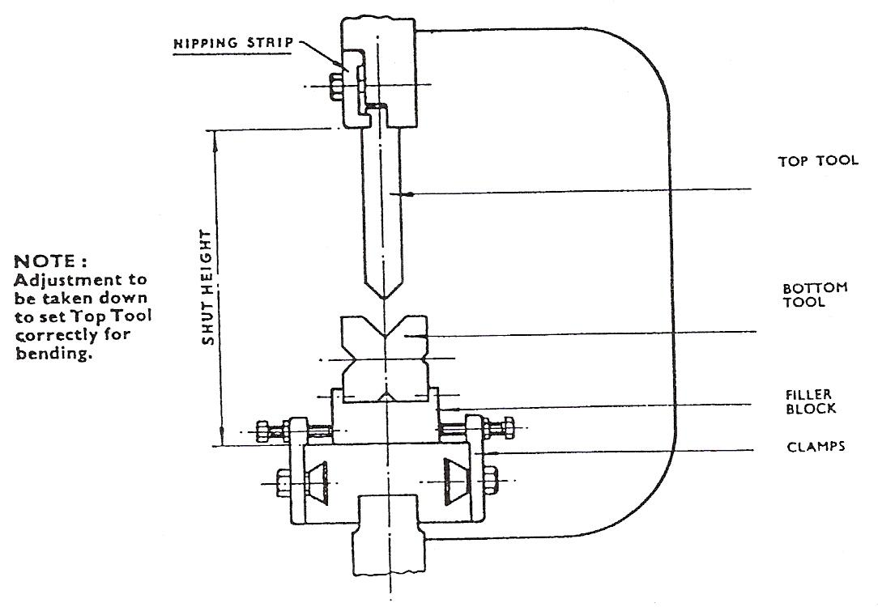
Figure 7 - Standard Tool Setup

The Shut Height of a Press Brake is the distance between the Top and Bottom Beams when the stroke is down at bottom dead centre and the Beam Adjustment screws are set to give the maximum space between the beams.
When designing Tools they should be arranged for a total Closed height (with Tools together) of slightly less than the Shut Height of the Press.
Thus for a Press shut height of 11 inches the Tools should be ideally designed with a closed height of about 10½ inches.
When ordering Tools for an existing Machine always quote the Bronx Machine number so that the shut height can be checked.
In the case of Machines other than of Bronx manufacture please give the Shut Height, Stroke and Top and Bottom tool holding details.
Filler Blocks are used not only as a convenient method of holding the bottom Tool but also to enable smaller Tools to be used for general work, thus economising in tool costs and also reducing the weight of tools.
Filler Blocks also enable the Press to work under the best condition, i.e. with the main screws in as far as possible.

Standard Tang Detail
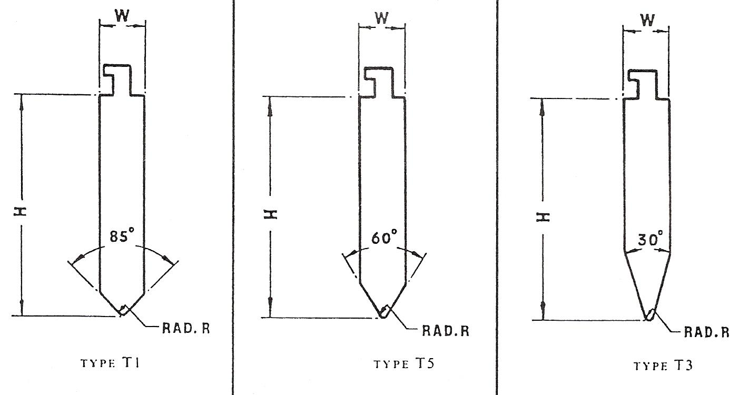
Figure 8 - Type T1, T5 and T3

Standard sizes.
Carried in stock lengths up to 14 feet.
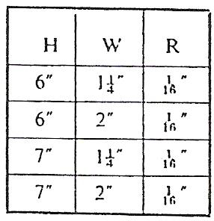
Table 3

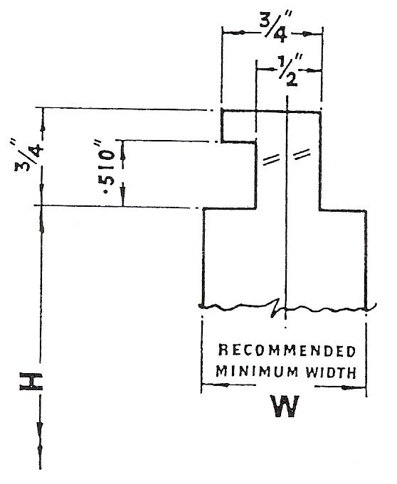
Note: Tool measurements H, W and R can be varied to suit Customer’s individual needs. Please specify requirements when ordering.

Suitable for all Bronx Press Brakes.
Special tangs can be supplied if required.
Reversible lips can also be fitted when necessary.

Bronx Standard Bottom Tools
Bronx standard Bottom Tools cater for a range of material thickness, increasing in size with the tonnage capacity of the Press.
Each standard Tool has a different sized vee in each of its four working faces. The Tools can be turned round to bring any desired vee into use.
For the choice of the correct vee size see table below.
Tools with special vees of any shape or size can be supplied on request.
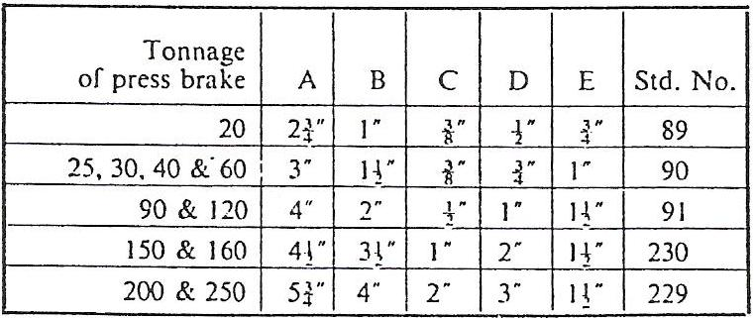
Table 4
Alternative versions of these Bottom tools are available incorporating a 30° vee.
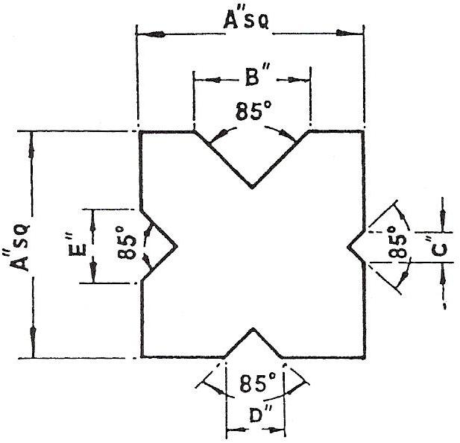
Figure 9 - Type B1

Correct Size of Vee for Each Gauge
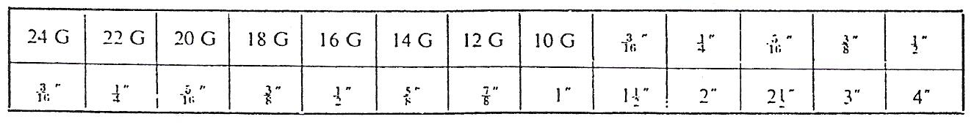
Table 5 - Size of Vee Width or Opening for Various Gauges (8:1 Die Ratio)

The Golden Rule
The golden rule for Tool changing on Press Brakes is placed clearly before the Operator on the top beam of all Bronx Press Brakes in the form of a large plate:
DANGER - CHANGE TOOLS ONLY WITH TOP BEAM AT BOITOM OF STROKE.

It will readily be appreciated that if this rule is not strictly adhered to the Machine could be operated with Tools set too close together for the shut height of the Machine, with a consequent danger of severe overloads and damage to the Machine, or the possibility of stick-up with the Machine jammed at the bottom of the stroke.

Make sure therefore that your Setter/Operator understands and observes this Golden Rule when Tool changing and setting.

Tool Setting
Assuming that the Tools have been fitted into the Machine the next step is to adjust them to produce the correct and accurate form or bend desired.
1. Position along the beam
Short Tools, particularly those of high loading capacity, are best positioned in the centre of the beam length of the Press Brake. Having positioned the top and bottom Tools one below the other lengthwise the next important step is…

2. Vertical line-up
The top and bottom Tools must line-up vertical1y. Should the centre line of the top Tool be off centre with the Vee opening in the bottom Tool then an imperfect bend will result, and the metal will be pinched more on one side than the other. The same principle is true of any Tools whether of the simple angle bending type or not. Except in special cases where side thrust pads, guide columns, or kicking steps are used, always remember that there must be no side thrust on the Tools due to vertical misalignment.
The Top Tool is usually designed to be fixed rigidly to the top beam by the nipping strips provided, and care should be taken to ensure that the top Tool is fixed in position with its shoulders hard up against the underside of the top beam.
The Bottom Tool should then be aligned to the Top Tool by means of the side clamping and adjusting screws, which are positioned at intervals along the bottom beam.

3. Setting for gauge thickness
Using feeler gauges or sample pieces of the gauge of metal to be formed, adjust the top beam up or down by means of the mechanical adjustment provided so that the correct gauge thickness is obtained between the top and bottom Tools on both sides of the Tools. Ensure that the same setting is achieved at both ends of the Tools.

CNC Coursework Assessment

Assignment No:

DATE: ________________________________ DRAWING NO: _______________

TIME:_________________________________ PART NO: ____________________

MACHINE: ____________________________ MATERIAL: __________________

JOB NO:_______________________________ BEND ALLOWANCE: __________

CUSTOMER:___________________________ TOOL CLEARANCE: ___________

SHEET SIZE:___________________________

CLAMP POSITION (1) ___________________ (2) ___________________________

BEND ALLOWANCE = __________________

BLANK LENGTH =______________________

POSITION OF BENDS = __________________

BEND SEQUENCE =_____________________

NEUTRAL LINE RADIUS =_______________

Self Assessment
Questions on Background Notes – Module 7.Unit 6

The instructor is to dismantle Punch Press and Press Brake tooling and reassemble the same as a demonstration.

1. What is the Maximum diameter for:

A Type Tooling
B Type Tooling
C Type Tooling

2. When selecting tooling for the Punch and Press Brake what three essentials do we
consider?

Answers to Questions 1-2. Module7.Unit 6

= Diameter. E.g. 15 Diameter = 15

1.

Type A - 15
Type B - 40
Type C - 100

2.

Material Type

Material Thickness

Shape of Workpiece, e.g. size of workpiece.

Index

B
Bronx Standard Bottom Tools, 18
C
CNC Coursework Assessment, 20
Combination of Dies and Punches, 11
Correct Size of Vee for Each Gauge, 18
F
Formula for Loads for Air-Bends, 14
H
How to Read the Pressure Chart, 13
M
Material Handling, 10
P
Press Brake Geometrics, 10
R
Reduce your Forming Costs with Standard, 12
S
Self Assessment, 21
Standard Tang Detail, 17
Standard Tool Setup, 16
T
The Golden Rule, 19
Tool Selection for Punch/Press Brake, 10
Tool Setting, 19
Tooling, 8
Tooling Types, 8

